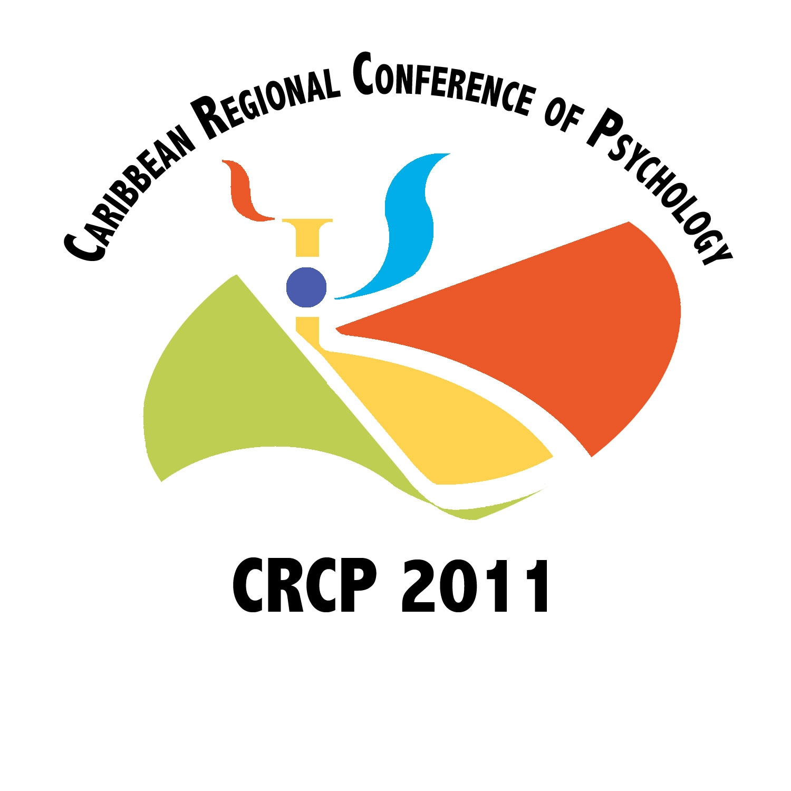

November 15-18, 2011
Nassau, Bahamas
Call for Submissions
Call For Papers

Conference Theme:
Psychological Science & Well-Being: Building Bridges for Tomorrow

Early Submission Deadline: November 30th 2010
Regular Submission Deadline: January 30th, 2011

The 2011 Caribbean Regional Conference of Psychology is being hosted by the Bahamas Psychological Association (BPA), under the auspices of the International Union of Psychological Science (IUPsyS), with the collaboration of the International Association of Applied Psychology (IAAP) and the International Association for Cross Cultural Psychology (IACCP). CRCP 2011 is being organized to promote the growth of psychology in the Caribbean, strengthen regional bonds and national organizations, and support Caribbean psychology’s increased engagement with the global psychological community.

The conference theme, “Psychological Science & Well-Being: Building Bridges for Tomorrow,” reflects an appreciation for psychological science as a critical instrument for building bridges across time, disciplines, regions, research areas, and communities; through policy, advocacy, education, publication, and teaching; and for change, development and empowerment of individuals and communities.

The CRCP invites Caribbean psychologists (academics and practitioners), students and trained psychologists working in other fields, in the region and the Caribbean diaspora, to submit abstracts of research that embraces and affirms the cultural realities of the Caribbean peoples and promote their mental health and overall well-being. Abstracts are also welcome for research that highlights the advancement, critical issues, needs and opportunities for psychological science in the region, and integrates the research, teaching, and practice components of the discipline.

The CRCP also invites psychologists from around the world to submit abstracts that are relevant to the experiences of the Caribbean peoples and contribute to the development of a culturally-appropriate, diverse and global psychological science.

sub-themes and topics
Abstracts are welcome on any of the following six sub-themes. The conference also welcomes submissions that embody the sentiments reflected in the overall conference theme but which are not captured in the sub-themes and topics below.

Caribbean Culture and Psychology
Identity
Family: evolving structures, adaptation, challenges,
Child rearing ethnotheories and practices
Caribbean worldviews: attitudes, beliefs & values
Historical and contextual factors
Spirituality & well-being
Rhythm and resilience

Caribbean Building in the Caribbean Region
Building graduate programmes in psychology
Building organizations of psychology
Building a regional network
Building bridges for tomorrow

Education & Training
Culturally-responsive instruction
Diversity & multiculturalism in psychology education
Internationalizing the psychology curriculum
Student learning outcomes
Evaluating teaching effectiveness
Programme/curricular evaluations
Graduate and undergraduate training: Best models

Mental Health and Development
Culturally-relevant mental health assessment
Disasters and mental health
Nontraditional community-based intervention
Clinical intervention: Integrating culture
Mental health promotion and wellness models
Mental health disorders across the lifespan

Research Methodologies
Evidence-based practices
Community-based participatory research
Ethnography
Quantitative, qualitative and mixed methods
Ethnocultural diversity in research
Ethics in research
Research in the Caribbean: Issues, progress & challenges

Psychology in the Public Interest
Youth development: Challenges and progress
Psychology in the educational system
Psychological health and organizations: The work environment
Health care issues: HIV/AIDS, stress, hypertension, disability etc
Mobility of Caribbean peoples
Promoting mental health awareness and reducing stigma
Social Issues: Crime, sexuality, violence, substance abuse, institution-based persons

Ethics in professional practice

FORMATS
Abstracts may be submitted for four types of sessions.
- Poster Presentations. Poster sessions allow presenters to provide a synopsis of their work in visual form and promote informal discussion about the work with poster session attendees. Poster presentations will be grouped into larger sessions.

- Papers (15 minutes). Paper presentations will be grouped into topically related symposia. Individual papers may also be assigned as poster presentations or roundtables.
- Symposia (90 minutes). Each integrated symposium generally includes a maximum of four (4) presentations on a common topic and may include a discussant. The symposium abstract must include the symposium goals and objectives and an overview of the papers. A separate abstract for each paper is also required.

- Roundtables (45 minutes). In this format, presenters will open a discussion on a topic relevant to the conference theme with brief remarks and facilitate a guided, interactive discussion with the roundtable participants. Abstracts must clearly outline a framework or guiding points for what will be discussed.
Abstracts are required for all formats. All poster, paper and roundtable abstracts must include a title (10 word maximum) and a summary of no more than 250 words. Symposia abstracts must include a symposium title, an abstract of no more than 500 words, and separate paper abstracts for each presentation.

HOW TO SUBMIT AN ABTRACT
Submit the CRCP Abstract Submission Forms, including the Contact Information Sheets and the abstract(s), via email to abstractsubmission@crcp2011.org. Be sure to identify the principal author/contact and include all authors’ names, titles, affiliations, and contact information. Please note that only abstracts submitted via email will be considered.

CONFERENCE LANGUAGE
English is the official language of the Conference but abstracts will be accepted in Creole, French, Spanish & Dutch.

REVIEW CRITERIA
All abstracts will be reviewed on the basis of relevance to the overall conference theme, clarity of scientific questions and evidence of methodological rigor. Abstracts for empirically-based presentations must include the specific goals of the study, the research questions, methodology, a summary of the results if analyses have already been completed, and a conclusion. While it is not necessary for analyses to be completed prior to abstract submission, data must have been collected. Abstracts for theoretical, educator, or practitioner-based presentations must clearly describe the issue, project, intervention, or educational experience that is at a reasonably complete stage.

NOTIFICATION OF DECISIONS
Authors who submit abstracts by the early submission deadline (November 30th 2010) will be notified, via email, of decisions by January 14th, 2011. Those who submit abstracts by the regular submission deadline (January 30th 2011) will receive email notification of decisions by April 15th, 2011.

PRESENTER POLICY
All paper, symposia, roundtable and poster presenters must be registered participants in the conference and are responsible for their own travel and accommodation costs.

There will be special conference accommodation rates for registered participants at the conference hotel.

Conference Website:
www.crcp2011.org

For questions or assistance, please contact:
info@crcp2011.org

